# Table of Content

Table of Content 1

Introduction 2

Prototype Functionality 2

User Authentication System 2

Interactive Event Planner 3

Background Technologies 3

Bootstrap 4 3

Custom CSS 3

JavaScript Libraries 4

Practical Implementation 5

Login Page: 5

Main Event Page 6

Heuristic evaluation and Usability tests…………………………………………………………………….7

Discussion 7

Conclusion 7

References 8

# Introduction

Tourism has become a lively and magnetizing industry attracting thousands of people every year to see and experience the fascinating destinations. This new website's development is a result of an innovative tourism website designed for individuals who are into nature and enjoy it as a hobby. Shaping the model, we will essentially be providing direct market solutions in a personalized and concise manner which is unrivalled currently. Sites and platforms where posted content is either unrelated, bland, and missing a personal touch, or too much of a challenge for newcomers are not so popular. Our user-friendly interface makes the planning process easy to understand, which increases usability, customization, and the simplicity of the design. The website seeks to provide the users with a toolkit with which to plan, organize and manage their tours efficiently. The aim of this is to improve the travel experience such that the tours are well-planned for the tourists and pleasurable to do.

# Prototype Functionality

The prototype of our tourism website is based on a vertical design, which is focused on delivering the features that are the main reason for our website's existence. This approach is crystallized through the implementation of two primary features that form the backbone of our platform: it has the User Authentication System and the Interactive Event Planner.

## User Authentication System

The User Authentication system spans the spectrum of login, sign up, and user profile management functionalities as part of the more comprehensive feature set. The key advantage of this aspect is that it gives a user a chance to get a customized experience. Firstly, signed in users will save their choices, arrange their event schedules, and can also have their history of activities via the platform, this will help them in a more thorough experience of their tourism. An opportunity to integrate such a capability is in the system's nature as it helps achieve service personalization. Not only does it make the content relevant to users only but also it secures user data and thus creates a trustworthy and reliable platform for users. For a start, the user registration procedure we had previously consisted of a mandatory questionnaire that was both long-ranging and unappealing to potential users, according to their feedback. By removing the extra requirements, which can intimidate those who want to take part, it will make the system more accessible, and the user-entry process can be simplified and quicker (Jaiswal & Jaiswal, 2022).

## Interactive Event Planner

Our main feature, the Interactive Event Planner, excels at involving users with the map which enables them to choose the locations and see the related activities or events. This functionality prevents the user from forgetting the events by recording new events on the calendar, bookmarking important events for future reference, or managing the schedule using the well-arranged tool. This tool can be considered as direct support to niche travelers who prefer such organized activities which fall into the range of their hobbies or specific interest and these travelers may want to know if they need to book some additional things. The initial plan of this feature faced problems both in performance and user overload since the map at first loaded all the available events at once. It made the systems become less efficient and users couldn't cope at the level they were supposed to. Thus, this was what we implemented, to load the events dynamically based on the selection from the user of the specific interest of the area of the user. This dramatically improved response time while providing a plastic experience for the user.

# Background Technologies

The tourism website is being created using various technologies which are presented in the market and some of the technologies help to make our work easier. The technologies are:

## Bootstrap 4

Bootstrap 4 has been partly incorporated into our project to utilize its mobile-first grid system and ready-to-use components, which make it easier to create a responsive design that adjusts well across different devices. Helping the design stay visually attractive is the main function carried out by Bootstrap, but it’s the same solution that lets us make a consistent layout and make the users experience easy and comfortable (Ganguly, 2023).

## Custom CSS

Though Bootstrap has few pros in it, our prototype still follows largely by the custom CSS to do the styling. Thus, this decision was made to obtain better handle of the design aspects, which will enable us to create more individualized and distinctive visual elements that will correspond closely to the theme and the requirements of our hobbyist tourism platform. Through personal CSS mastery, we would be able to adjust user interfaces and prepare a special and distinctive look that is guaranteed not to be found on other websites where Bootstrap standard themes are used (Abramowski et al., 2023).

## JavaScript Libraries

jQuery is essential for our prototype and becomes the major framework which offers efficiency, reliability, and easy extensions. The reason for the jQuery choice was its simplicity and power in HTML document manipulation, event management, and Ajax interactions. This technology allows us to not gather the users’ attention continuously but make them constantly participate in the interaction with the website in real-time by avoiding page reloads. jQuery also is integrated in the development of various web platforms. Due to its universal acceptance and huge number of plugins it has become a stable option for accelerated development and implementation of different features (Mwakalinga, 2021).

The Bootstrap for the basic structure, custom CSS for the unique styling, and jQuery for the dynamic content management were the chosen components to strike a balance between the development efficiency and the customizability. Such technologies would be chosen in terms of their reliability, vast community support and the excellent documentation that expedites the development process and ensures the code's quality and maintainability. We envisioned setting up the technology stack in such a way that we could have easily built the platform and met the needs of our users when it comes to both clear-cut and user-friendly features.

# Practical Implementation

Our tourist’s website design is structured on several main pages to which easy access, clear layout, and functionality are applied for simple navigation. Here's a walkthrough of three main pages with their respective features and navigation paths:

## Home Page:

## Login Page:

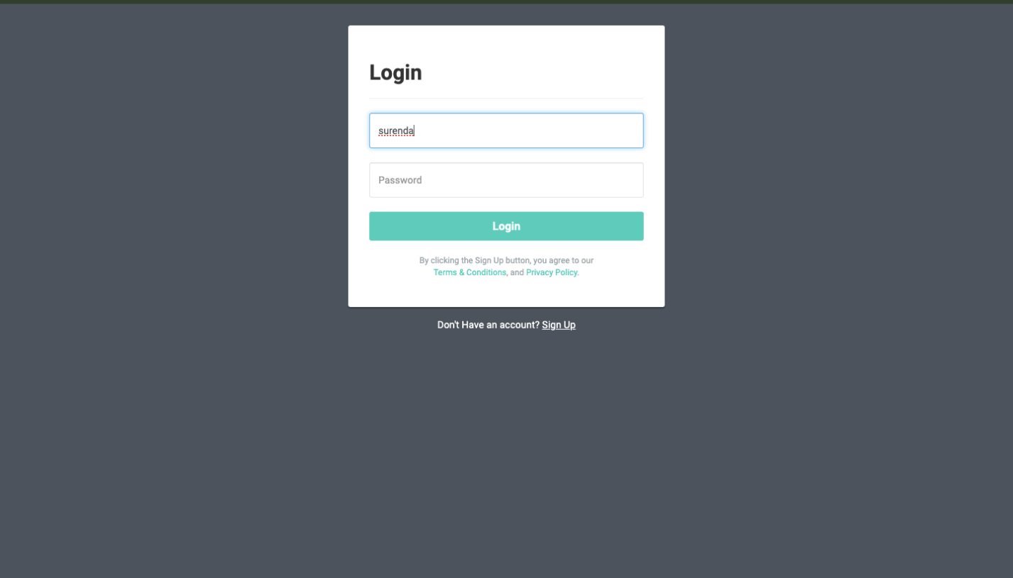

The login page is the website's main door used to enter the credentials, which later allow users to access the personalized settings and event schedules. This page consists of two fields interview for username and password which also contains extra option for the users to stay in the system they will just check the checkbox that says," Remember Me " and the other are for the ones who need their passwords to be resend or they haven't register yet. When you enter the correct credentials, you are then shown your main screen. This change makes the site easy to navigate and allows access to the different sections of the site such as the event map, profile settings, and saved events. The main goal of the login page design is to facilitate the accessibility using high contrast colors for easy visibility, text labels for all fields of the forms, as well as accessible controls, which ensures the user's ability to use the page regardless of level of capability.

Main Event Page

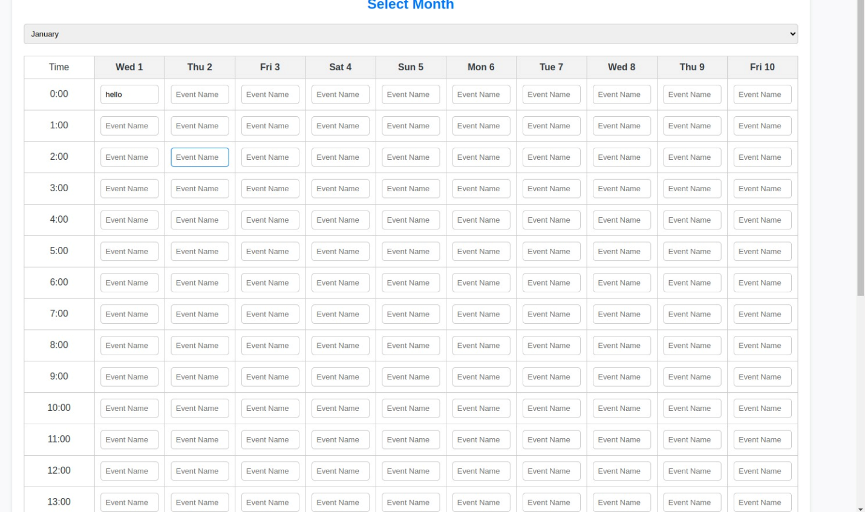

The main core page of the website is the Event page, a central stage around which the interaction of users takes place. A map at this place has interactivity, so clicking on the spot's designers mark in real life as event locations shows different activities. The event details are easy to access, and users can add them to their calendar or save them for future reference. The app's launch screen is simple, yet elegant, with accessible buttons leading to in-depth event excerpts, users' calendar, and a giveaway list. For user friendliness, map controls are all keyboard-operable and screen-reader-compatible, consequently enabling all users of different physical abilities to conveniently maneuver and interact with the map as desired.

# Heuristic evaluation and Usability tests results

1. Introduction

To ensure the usability and effectiveness of our tourism website, we conducted a heuristic evaluation using Nielsen’s 10 Usability Heuristics and a series of usability tests with end-users. This section presents the results of these evaluations and discusses their impact on the final design.

We created a [Google Form](https://forms.gle/bKoEKuHh4ZrKxxxh6) to collect feedback from participants. The form can be accessed here.

2. Heuristic Evaluation

Summary of Feedback:

* Visibility of system status: Users found the system status to be always generally visible. However, they suggested adding a loading indicator during data processing tasks to enhance clarity.

Severity: 1 (Cosmetic problem only)

* Match between system and the real world: The terminology used was mostly well-understood, though some users suggested simplifying certain technical terms to better align with everyday language.

Severity: 1 (Cosmetic problem only)

* User control and freedom: Users appreciated the presence of undo and redo options but indicated that these options should be more prominently displayed.

Severity: 2 (Minor usability problem)

* Consistency and standards: Most interface elements followed consistent design patterns. However, a few inconsistencies in button placement were noted.

Severity: 3 (Major usability problem)

* Error prevention: Users highlighted that while most forms had validation checks, there were instances where more detailed error messages could prevent user errors.

Severity: 3 (Major usability problem)

* Recognition rather than recall: The design effectively utilized icons and prompts to minimize the reliance on user memory. However, some icons were not immediately recognizable.

Severity: 2 (Minor usability problem)

* Flexibility and efficiency of use: Users found the shortcuts helpful but suggested more customizable options to cater to experienced users.

Severity: 2 (Minor usability problem)

* Aesthetic and minimalist design: The design was praised for its clean and minimalist approach. Some users suggested reducing the amount of text on certain pages to avoid clutter.

Severity: 1 (Cosmetic problem only)

* Help users recognize, diagnose, and recover from errors: Error messages were generally clear but could benefit from more specific guidance on how to resolve issues.

Severity: 2 (Minor usability problem)

* Help and documentation: While help documentation was available, it was not always easy to find. Users suggested adding a more prominent help section.

Severity: 2 (Minor usability problem)

Severity Rankings:

* Issue 1: Unclear error messages in forms. - Severity: 2
* Issue 2: Inconsistent placement of navigation menu items. - Severity: 3
* Issue 3: Some icons not immediately recognizable. - Severity: 1
* Issue 4: Lack of loading indicator during data processing. - Severity: 2
* Issue 5: Help documentation not easily accessible. - Severity: 3

3. Usability Testing

Test Scenarios:

* Scenario 1: Signing up for a new account.
* Scenario 2: Logging into an existing account.
* Scenario 3: Using the Interactive Event Planner to add an event.
* Scenario 4: Navigating the map to find and bookmark events.

Test Results:

* Participant 1: Found the sign-up and login process straightforward but had difficulty locating certain features on the map.
* Participant 2: Suggested adding more detailed descriptions for events and found the navigation menu inconsistently placed.
* Participant 3: Appreciated the minimalist design but noted that some icons were not immediately recognizable.
* Participant 4: Experienced delays during data processing and suggested a loading indicator.
* Participant 5: Had issues with unclear error messages in forms and suggested more specific guidance.

Identified Issues:

* Issue 1: Difficulty in locating certain features on the map.

Severity: 3 (Major usability problem)

* Issue 2: Inconsistent navigation menu placement.

Severity: 2 (Minor usability problem)

* Issue 3: Unclear error messages in forms.

Severity: 2 (Minor usability problem)

* Issue 4: Lack of loading indicator during data processing.

Severity: 2 (Minor usability problem)

* Issue 5: Some icons are not immediately recognizable.

Severity: 1 (Cosmetic problem only)

4. Discussion

Impact on Design:

Based on the heuristic evaluation and usability testing, we have implemented several changes to improve user experience. These include adding a loading indicator during data processing tasks, simplifying technical terminology, ensuring consistent placement of the navigation menu, and making important features on the map easier to find. Additionally, we have improved the clarity of error messages and added more detailed event descriptions.

Conclusion:

The evaluations provided valuable insights that have significantly improved the usability of our product. We will continue to iterate on our design based on user feedback to ensure the best possible user experience. The feedback highlighted the importance of clear communication, consistent design patterns, and easily locatable features, all of which have been addressed in the updated design.

# Discussion

User feedback has played a very important role in adjusting the design. The positive responses received for the unusual product of interactive event planner boosted its power of functionality, thus resulting to having the further improvements. Because of criticisms expressed after the release of the information system about the difficulty of the user interface, there was a redesign that had the purpose of simplifying interactions and increasing the ease and intuitiveness of navigational elements. Despite some people criticizing it, some design elements were kept only when they followed the user experience strategy and technical feasibility.

# Conclusion

The prototype for the tourism website certainly integrates the specially tailored and necessary elements which the website users need when on a hobby tourism trip and an event planner mission. The user interface that is easy to use and the personalized features such as the interactive event planner have really improved the engagement of the users. Moving ahead the prototype would be anxiously updated in backend architecture as well the user feedback integration on continuation to the full-fledged solution of the user requiring handling larger population and additional features. The establishment of this prototype can therefore be described as a good starting point meant to meet the need of travelers wishing to have an online tool to plan for their voyages.

# References

Abramowski, N. *et al.* (2023) *What is CSS? A web developer’s guide for 2024*, *What is CSS? A Beginner’s Guide*. Available at: <https://careerfoundry.com/en/blog/web-development/what-is-css/> (Accessed: 13 May 2024).

Ganguly, S. (2023) *What is Bootstrap Responsive & How to use it?* Available at: <https://www.browserstack.com/guide/bootstrap-mobile-responsive> (Accessed: 13 May 2024).

Jaiswal, B. and Jaiswal, N. (2022) *19 must-have features for travel agency websites*, *WP Travel Engine*. Available at: <https://wptravelengine.com/must-have-features-for-travel-websites/> (Accessed: 13 May 2024).

Mwakalinga, J. (2021) *17 great articles about JavaScript*, *Medium*. Available at: <https://medium.com/we-code-we-write/17-great-articles-about-javascript-7c2a5f062ea3> (Accessed: 13 May 2024).